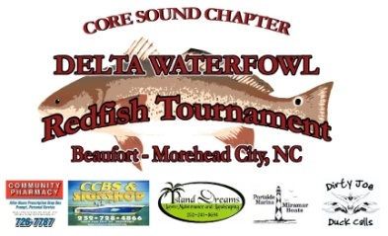
2011 Core Sound Chapter – Delta Waterfowl Redfish Tournament Entry Form
Mail Completed Entry Form enclosed with Check or Money-Order payable to:
Core Sound Chapter – Delta Waterfowl
189 Highway 101
Beaufort, NC 28516
Tournament Contact #: (252) 725-7777

TEAM NAME: _________________________________________________________________________
CAPTAIN’S NAME: ___________________________________ SSN#:_____________________________
ADDRESS: ____________________________________________________________________________
CITY: _______________________________ STATE: _______________ ZIP CODE: __________________
EMAIL: ____________________________________ PHONE: ___________________________________
CAPTAIN’S SIGNATURE: ______________________________________ DATE: ____________________

PARTNER’S NAME: ___________________________________ SSN#: ____________________________
ADDRESS: ____________________________________________________________________________
CITY: _______________________________ STATE: ______________ ZIP CODE: ___________________
EMAIL: ____________________________________ PHONE: ___________________________________
PARTNER’S SIGNATURE: ______________________________________ DATE: ____________________

CHECK ALL THAT APPLY:
CORE SOUND CHAPTER – DELTA WATERFOWL REDFISH TOURNAMENT ($150.00) _____________
TOURNAMENT WITHIN TOURNAMENT (*Must be registered in Main Tournament Event to enter)
LARGEST SINGLE FISH ($80.00) _____________
MOST SPOTS ($40.00) _____________
*SOCIAL SECURITY NUMBER IS REQUIRED FOR TAX REPORTING PURPOSES ONLY. ** TEAMS MAY PAY TO ENTER ALL THREE EVENTS AT ONCE OR CAN PAY INDIVIDUALLY FOR TWT EVENTS PRIOR TO FINAL REGISTRATION CUT-OFF ON OCTOBER 7, 2011 CAPTAIN’S MEETING – PLEASE NOTE THAT BY CHECKING ENTRY INTO EITHER TWT EVENT, YOU WILL BE REQUIRED TO PARTICIPATE OR YOU MAY BE DISQUALIFIED FROM MAIN TOURNAMENT EVENT & ENTRY FEE NOT REFUNDED . IT IS THE RESPONSIBILTY OF EACH PARTICIPANT TO READ & FULLY UNDERSTAND THE RULES GOVERNING THE CORE SOUND – DELTA WATERFOWL REDFISH TOURNAMENT. COMPLETE RULES CAN BE REVIEWED AT www.deltawaterfowlcoresound.org AND WILL BE EMAILED TO REGISTERED PARTICIPANTS WHO PROVIDE A VALID EMAIL ADDRESS. PARTICIPANTS MAY ALSO REQUEST A COPY TO BE DELIVERED VIA REGULAR MAIL BY MAKING A NOTATION AS SUCH ON THE RETURNED ENTRY FORM. THANK YOU FOR YOUR PARTICIPATION! CORE SOUND – DELTA WATERFOWL REDFISH COMMITTEE

