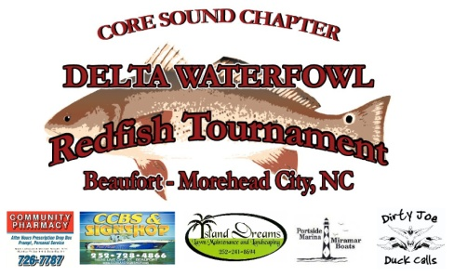
DISCLAIMER
YOU MUST SUBMIT THIS FORM COMPLETED TO BE REGISTERED IN THE CORE SOUND – DELTA WATERFOWL REDFISH TOURNAMENT OR ANY TWT (TOURNAMENT WITHIN TOURNAMENT) EVENTS.
Please read carefully and sign:

I, _______________________________________________________, Captain

And

I, _______________________________________________________, Partner of

_________________________________________________________, Fishing Team, understand that there are dangers associated with fishing and boating. We understand that these dangers may result in injury to person, and death. We understand that the activities associated with fishing and boating may result in property damage, injury and death. By signing this disclaimer, we do not hold the Core Sound Chapter – Delta Waterfowl Redfish Tournament, Core Sound Chapter of Delta Waterfowl, Delta Waterfowl Foundation, or any sponsors associated with the Core Sound – Delta Waterfowl Redfish Tournament, event coordinators, personnel assisting with the Core Sound Chapter – Delta Waterfowl, the hosting marina responsible for any accidents, injuries, property damage, or death that may occur while participating in any event or competition associated with the Core Sound Chapter – Delta Waterfowl Redfish Tournament.

All participants in the Core Sound Chapter – Delta Waterfowl Redfish Tournament enter at their own risk and agree to hold harmless the Core Sound Chapter – Delta Waterfowl Redfish Tournament, Delta Waterfowl Foundation, the hosting marina and any of their officials, committee members, committee chairman, sponsors or any person connected directly or indirectly with the Core Sound Chapter – Delta Waterfowl Redfish Tournament. Furthermore, these parties are exempt from any liability suffered to any participant, entrant, sports fisherman, captains, their guest or companions, vessel, or equipment, which may occur during the course of the Core Sound – Delta Waterfowl Redfish Tournament. Furthermore, I agree to abide by all local, state, and federal fishing and boating laws and regulations while participating in the Core Sound Chapter – Delta Waterfowl Redfish Tournament.

Also, I understand that I may be photographed (still and/or video) during the Core Sound – Delta Waterfowl Redfish Tournament, and I consent to the use of those photographs or video for the purpose of Core Sound Chapter – Delta Waterfowl Redfish Tournament, and Core Sound Chapter of Delta Waterfowl promotion. I understand and agree with the above paragraphs, and agree to abide by the Core Sound Chapter – Delta Waterfowl Redfish Tournament Rules.

Captain Signature ____________________________________________ Date _____________________

Partner Signature ____________________________________________ Date ______________________

PARENTAL / GUARDIAN CONSENT (IF PARTICIPANT IS UNDER 18)

___________________________________________________________ Date _______________________

